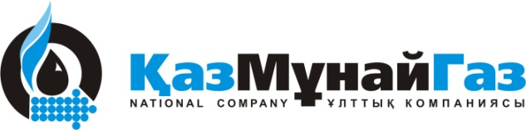
NATIONAL COMPANY KAZMUNAYGAS AND ROMPETROL HOLDING SA ANNOUNCE THE ACQUISITION BY KAZMUNAYGAS OF THE REMAINING 25% STAKE IN THE ROMPETROL GROUP NV

Amsterdam, 26th of June 2009 – JSC “National Company “KazMunayGas” (KMG) completed the acquisition of a further 25% equity interest of the The Rompetrol Group (TRG). Up to date this interest was beneficially owned by Rompetrol Holding SA. As a result of this transaction KazMunayGas becomes 100% shareholder of TRG.
Purchase of the share was conducted as a private transaction and is based on the terms of the initial agreement which was signed in August 2007, under which KMG acquired 75% stake in TRG from Rompetrol Holding SA.
President of JSC NC «KazMunaiGaz Kayrgeldy Kabyldin said: “The acquisition of the remaining stake in Rompetrol corresponds KMG strategy for the development of foreign assets”.

“KazMunayGas remain the largest foreign investor in Romania and will continue to implement investment projects of the Program for Reconstruction of Petromidia refinery, use of marine terminal at the port of Midia and expand the retail network of Rompetrol petrol stations in Romania and beyond”, - he stressed.

Dinu Patriciu stated: “Since August 2007, when KazMunayGas acquired a 75% stake in The Rompetrol Group, I have had the privilege to observe the extremely high level of knowledge, experience and, above all, commitment to the success of the company that KMG’s management has brought. I am confident that this is the best possible deal for the company, its shareholders, management and employees since KMG has the skills, resources and determination to take the company to its next stage of development. Over the years, we have built a modern and highly successful European oil company, presently operating in 13 countries and I know that KMG fully shares my commitment to this great company of which every Romanian can be proud”.
CONTACTS:
KazMunayGas
Galym Tumabayev
Tel.: + (77172) 976330
e-mail: g.tumabayev@kmg.kz
JSC “National Company “KazMunayGas” is the Kazakh national upstream and downstream operator representing the interests of the state in the petroleum sector of Kazakhstan. 100 percent of shares in JSC NC “KazMunayGas” are owned by JSC “Sovereign Wealth Fund "Samruk-Kazyna”.

Rompetrol Holding SA
Ivo Ilic Gabara
Tel.: + (44) 2031788013
e-mail: ivo@bgrgabara.com

