CFA Romania Macroeconomic Confidence Index, January 2018

Confidence: 46.0
December: 41.0; November: 44.1; October: 43.4; September: 45.4; August: 50.7; July: 59.7

Current conditions: 57.2
December: 59.0; November: 59.7; October: 59.1; September: 63.9; August: 68.6; July: 75.0

Expectations: 40.4
December: 32.0; November: 36.3; October: 35.5; September: 36.1; August: 41.8; July: 52.0

1. How do you consider current business conditions in Romania?

Balance: -6%
December: -8%; November: -10%; October: -7%; September: 16%; August: 20%; July: 36%

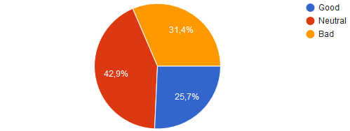
2. How do you consider the current employment situation in Romania?

Balance: 34%
December: 44%; November: 49%; September: 40%; August: 50%; July: 64%

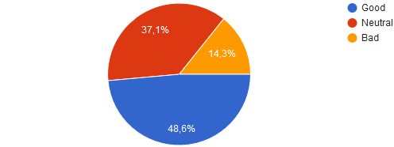
3. What are your expectations for business conditions in Romania in the next 12 months?

Balance: -57%
December: -72; November: -68%; October: -73%; September: -70%; August: -60%; July: -25%

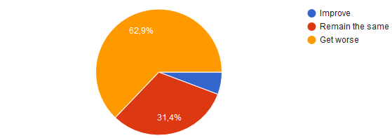
4. What are your expectations for employment situation in Romania in the next 12 months?

Balance: -43%
December: -46%; November: -39%; October: -34%; September: -35%; August: -31%; July: -5%
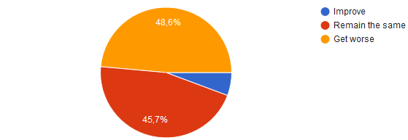
5. What are your expectation for personal income in Romanian economy in the next 12 months?

Balance: 6%
December: -18%; November: 12%; October: 0%; September: 10%; August: 17%; July: 14%
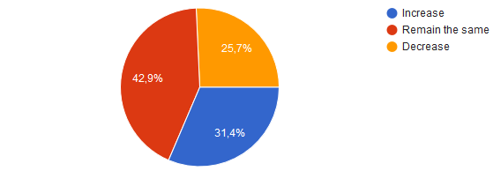
6. What are your expectation for personal wealth (stock market, real estate etc.) in Romanian economy in the next 12 months?

Balance: 18%
December: -8: November: -15%; October: -9%; September: -16%; August: 9%; July: 32%

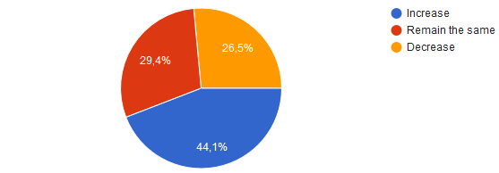
7. How do you estimate global macroeconomic conditions in the next 12 months?

Balance: 43%
December: 28%; November: 37%; October: 36%; September: 5%; August: 29%; July: 23%

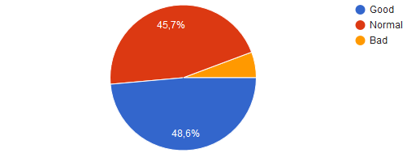
8. How do you estimate the annual inflation rate in Romania in the next 12 months?

Balance: 91%
December: 97%; November: 100%; October: 98%; September: 95%; August: 97%; July: 93%

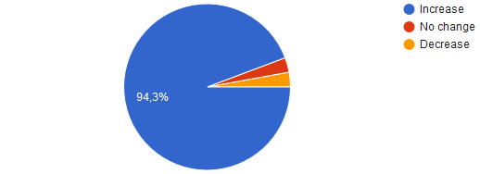
9. How do you estimate RON short-term interest rates (3-Month-Interbank rate) in the next 12 months?

Balance: 97%
December: 92%; November: 100%; October: 93%; September: 98%; August: 94%; July: 80%

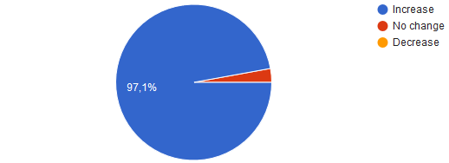
10. How do you estimate RON medium-term interest rates (yields on 5-Year bonds) in the next 12 months?

Balance: 92%
December: 92%; November: 98%; October: 91%; September: 100%; August: 88%; July: 77%

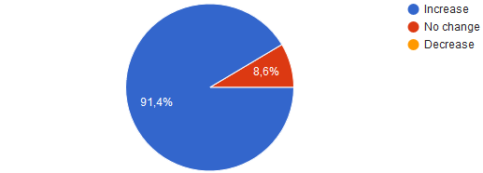
11. How do you estimate BET stock market index in Romania in the next 12 months?

Balance: 29%
December: -16%; November: -15%; October: -2%; September: -5%; August: -9%; July: 34%

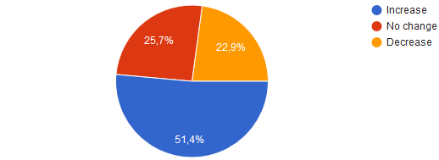
12. How do you estimate RON compared with EURO in the next 12 months?

Balance: -91%
December: -92%; November: -90%; October: -86%; September: -72%; August: -74%; July: -68%

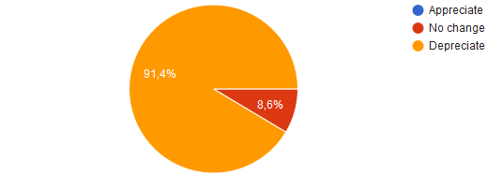
13. How do you estimate Brent spot oil price in the next 12 months?

Balance: 50%
December: 29%; November: 31%; October: 16%; September: 15%; August: 9%; July: 7%

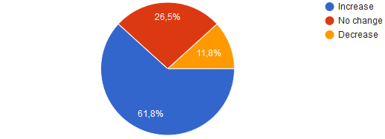
14. Do you expect at least one country to leave Eurozone in the next 12 months?

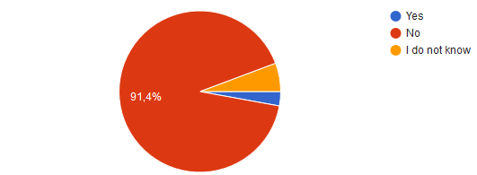

15. What is your EURRON exchange rate expectation in 6 months?

Average | 4.7168
Median | 4.7000
Min | 4.6500
Max | 4.8500

16. What is your EURRON exchange rate expectation in 12 months?

Average | 4.7643
Median | 4.7500
Min | 4.6000
Max | 5.0000

17. What is your annual inflation expectation in 12 months (Dec. 2018/Dec. 2017)?

Average | 3.71%
Median | 3.60%
Min | 2.00%
Max | 5.10%
Standard deviation | 0.74%

18. What is your ROBOR 3M interest rate expectation in 12 months?

Average | 2.95%
Median | 2.00%
Min | 2.10%
Max | 5.00%
Standard deviation | 0.75%

19. What is your expectation for 5Y Romanian sovereign bond RON yields in 12 months?

Average | 4.60%
Median | 4.50%
Min | 3.95%
Max | 6.00%
Standard deviation | 0.59%

? 100 – full confidence, 0 – no confidence, 50 - neutral
? Difference between “Good” percentage points and “Bad” percentage points

